RACE DESCRIPTION:
The road race will be held on the frontage (Hwy 91) south of Butte between Feely and Melrose (same course as last year). Registration is from 10:00 AM – 11:00 A.M; the race will begin at 11:15 A.M. Place race numbers on the right side of jersey.

All USCF Rules Apply
- Race Day registration only
- Fee is $20 – Juniors $10
- Racing Starts at 11:15 AM
- One-day license will be available for $10
- Racers who do not possess a permanent MBRA race number must purchase a one-day number for $2.
- MBRA membership applications will be accepted at registration, but racers will not receive numbers or race credit until the next race.
- Promoters reserve the right to combine classes
- Total prize purse $500 – Prizes must be collected at Awards Ceremony (no prize money will be mailed).
- Chief Official – Steve Dolberg

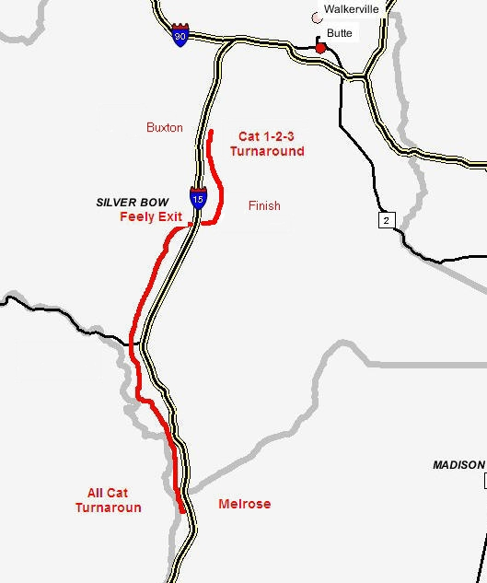
DISTANCES:
Sr. Men 1-2-3 11:15 AM 51 Miles
Sr. Men 4-5 11:20 AM 40 Miles
Masters (A, B, C) 11:20 AM 40 Miles
Women All Cat. 11:25 AM 40 Miles
Juniors 11:25 AM 40 Miles

Directions to Feely (Registration)
From Butte, take I-90 west towards Missoula. After 5 miles, you will see the I-15 South (Idaho Falls) exit, take it. Travel south for 9 miles to the Feely exit (Exit 111); take this exit and turn west (right). Registration will be near the beginning of the dirt road.

For Information Contact:
John Coulthard
(406) 723-7606
Email: sherrycoulthard@in-tch.com
Web site: www.highlandscycling.org

